AgriSens - Smart Farming Assistant
System Workflow Report

1. Executive Summary
AgriSens is an innovative AI-powered smart farming assistant designed to help farmers improve productivity and make data-driven decisions. The platform integrates two core machine learning modules:
- Smart Crop Recommendation System – Suggests optimal crops based on soil nutrients and environmental conditions
- Plant Disease Identification System – Diagnoses plant diseases from uploaded leaf images using deep learning
Both systems are deployed as interactive web applications using Streamlit framework.

2. Smart Crop Recommendation System
2.1 Purpose
To recommend the most suitable crop for cultivation based on soil composition and climate conditions.
2.2 Input Parameters
Parameter | Description | Range
Nitrogen (N) | Nitrogen content in soil | 0 - 140
Phosphorus (P) | Phosphorus content in soil | 0 - 145
Potassium (K) | Potassium content in soil | 0 - 205
Temperature | Average temperature (°C) | 0 - 51
Humidity | Relative humidity (%) | 0 - 100
pH Level | Soil pH value | 0 - 14
Rainfall | Annual rainfall (mm) | 0 - 500
2.3 Workflow
Step 1: User opens the Crop Recommendation web application.
Step 2: User enters the seven input parameters in the sidebar panel.
Step 3: User clicks the "Predict" button.
Step 4: The system processes inputs through the Random Forest classifier model.
Step 5: The recommended crop is displayed on the screen.
2.4 Screenshot - Crop Recommendation Interface
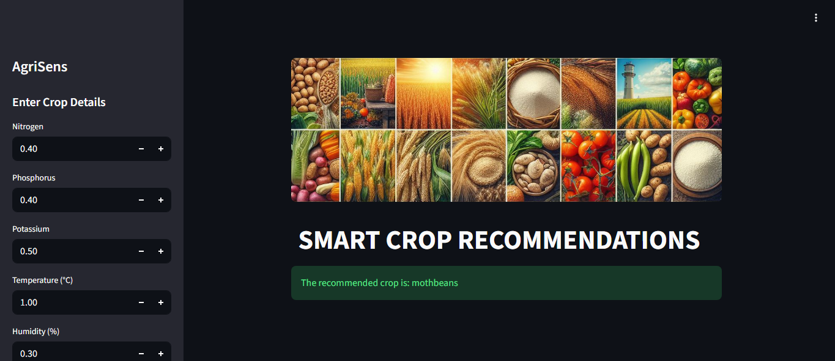
2.5 Machine Learning Model Details
Attribute | Details
Algorithm | Random Forest Classifier
Number of Estimators | 20
Training Accuracy | 99.55%
Dataset Size | 2,200 samples
Number of Crop Classes | 22 crops
2.6 Supported Crops
Rice, Maize, Chickpea, Kidney Beans, Pigeon Peas, Moth Beans, Mung Bean, Black Gram, Lentil, Pomegranate, Banana, Mango, Grapes, Watermelon, Muskmelon, Apple, Orange, Papaya, Coconut, Cotton, Jute, Coffee
3. Plant Disease Identification System
3.1 Purpose
To identify plant diseases from leaf images using Convolutional Neural Networks (CNN), enabling early detection and timely intervention.
3.2 Workflow
Step 1: User opens the Disease Identification web application.
Step 2: User selects "DISEASE RECOGNITION" from the sidebar menu.
Step 3: User uploads an image of the plant leaf.
Step 4: User clicks "Show Image" to preview the uploaded image.
Step 5: User clicks "Predict" to analyze the image.
Step 6: The CNN model processes the image and returns the disease classification.
Step 7: The diagnosis result is displayed on the screen.
3.3 Screenshot - Disease Identification Home Page
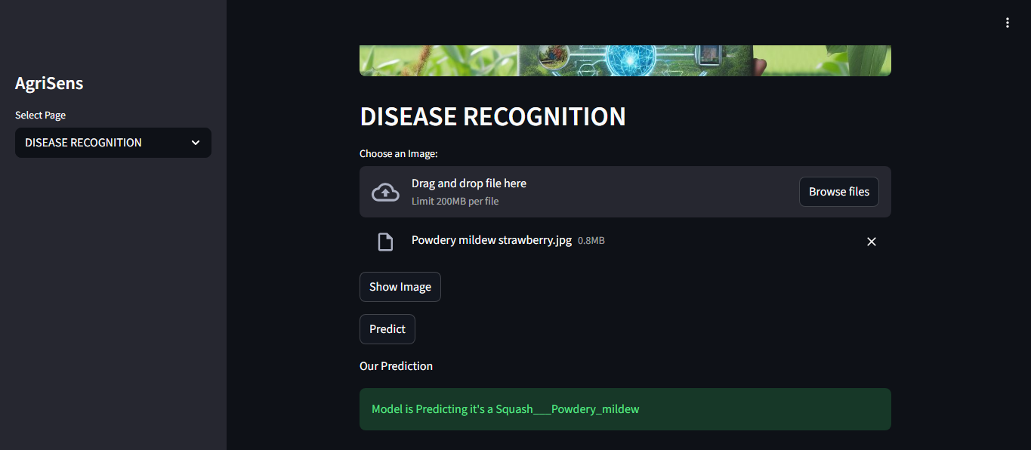
3.4 Screenshot - Disease Image Uploaded
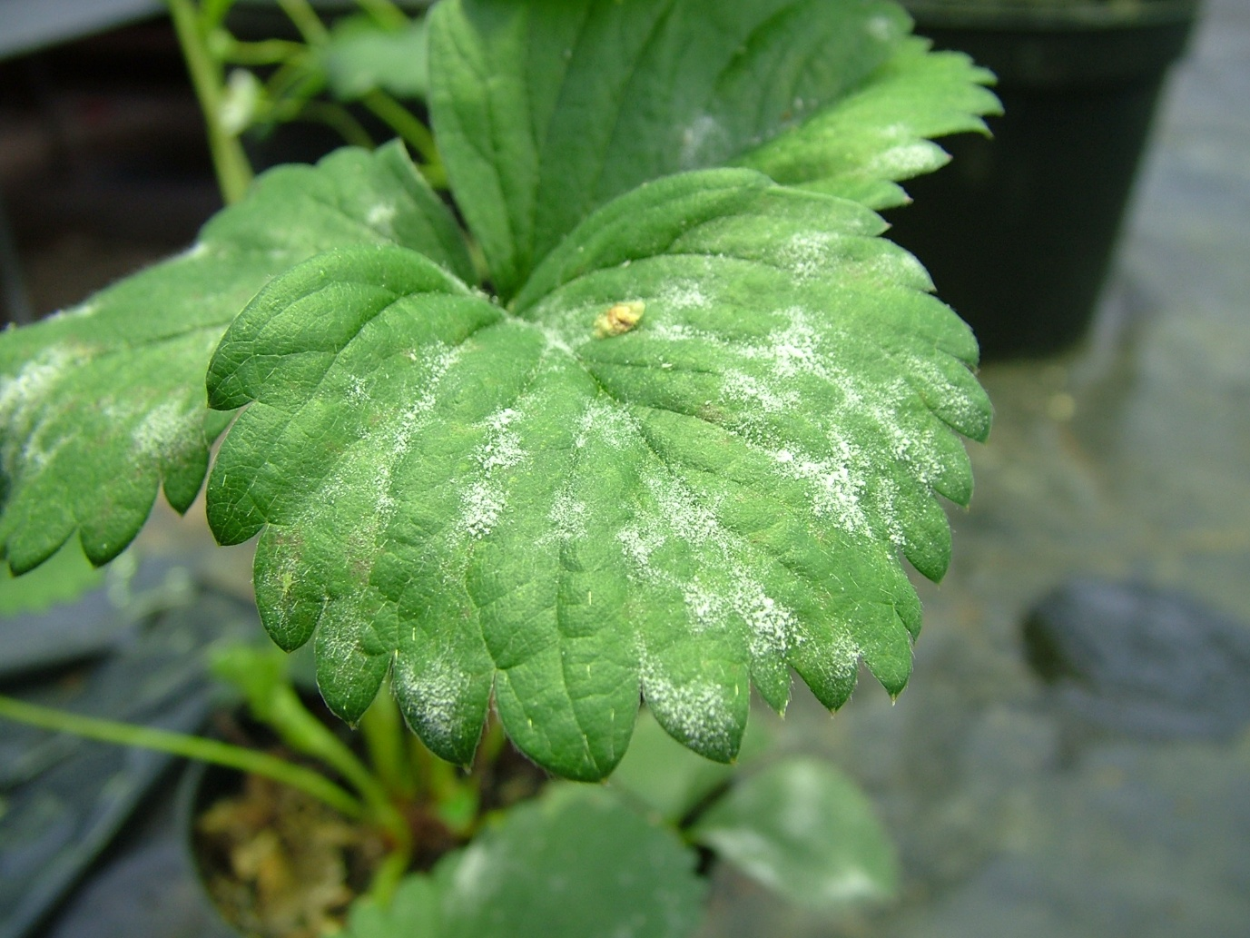
3.6 Deep Learning Model Details
Attribute | Details
Model Type | Convolutional Neural Network (CNN)
Framework | TensorFlow / Keras
Input Image Size | 128 x 128 pixels
Model Format | .keras
Training Images | 70,295
Validation Images | 17,572
Number of Disease Classes | 38
3.7 Supported Plants and Diseases
Plant | Diseases Detected
Apple | Apple Scab, Black Rot, Cedar Apple Rust, Healthy
Blueberry | Healthy
Cherry | Powdery Mildew, Healthy
Corn (Maize) | Cercospora Leaf Spot, Common Rust, Northern Leaf Blight, Healthy
Grape | Black Rot, Esca (Black Measles), Leaf Blight, Healthy
Orange | Huanglongbing (Citrus Greening)
Peach | Bacterial Spot, Healthy
Pepper (Bell) | Bacterial Spot, Healthy
Potato | Early Blight, Late Blight, Healthy
Raspberry | Healthy
Soybean | Healthy
Squash | Powdery Mildew
Strawberry | Leaf Scorch, Healthy
Tomato | Bacterial Spot, Early Blight, Late Blight, Leaf Mold, Septoria Leaf Spot, Spider Mites, Target Spot, Yellow Leaf Curl Virus, Mosaic Virus, Healthy

4. Technical Architecture
4.1 Technology Stack
Component | Technology
Frontend Framework | Streamlit
Programming Language | Python 3.12
ML Library | Scikit-learn
Deep Learning | TensorFlow, Keras
Data Processing | NumPy, Pandas
Visualization | Matplotlib, Seaborn
Image Processing | OpenCV, PIL

5. Conclusion
AgriSens successfully integrates machine learning and deep learning technologies to provide farmers with:
- Accurate Crop Recommendations – Using Random Forest algorithm with 99.55% accuracy
- Reliable Disease Detection – Using CNN to identify 38 different plant conditions
- User-Friendly Interface – Simple web-based interface accessible via any browser
- Real-Time Predictions – Instant results for quick decision making

